**Name: _____________ IPad # _________**

**Topic #7**

**Kinetics and Reaction Rates**

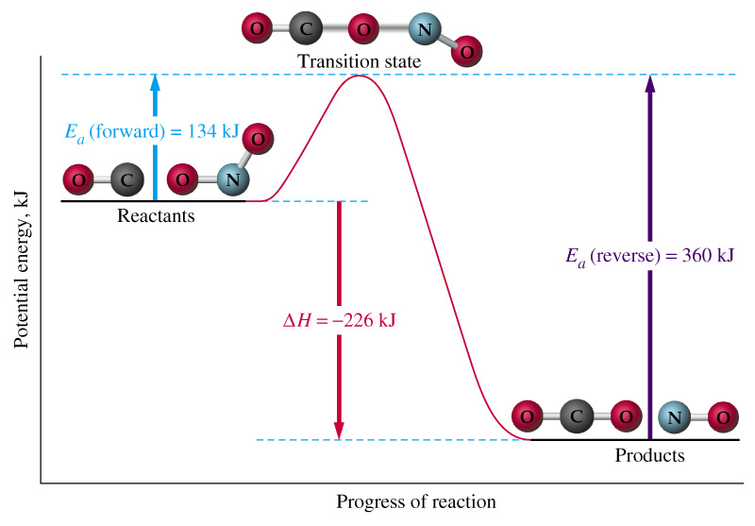

# Answer Key

**Kinetics and Reactions Rates Homework**

**Part I: Making Products-Colliding Particles**

Using your glossary, define ***collision theory.***

Atoms, ions, and molecules can react to form products when they collide, provided that the particles have enough kinetic energy.

Look at the figures below. One shows a collision that results in the formation of product.  
Label it ***effective collision***. Label the other collision ***ineffective collision***.

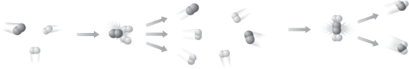

Ineffective Collision Effective Collision

List three conditions that will promote effective collision during a chemical change.

1. Sufficient energy

2. Right amount of speed

3. Proper angle of collision

**Page 601**

#4 No, the collision must have sufficient energy to break and form bonds.

**Part II: Quick Review of Parts of a Chemical Equation**

**Fill in the blanks.**

* A chemical equation represents a chemical change.
* The reactants are the substances you begin with before a chemical change has taken place.
* The products are the substances you end with after a chemical change has taken place.
* A double-sided arrow represents a reversible reaction.
* An arrow facing upward at the end of a reaction represents a formation of a gas.
* An arrow facing downward at the end of a reaction represents a formation of a precipitate.

**Part III: Overall Change in Enthalpy (Heat Content) During a Chemical Change**

Using your glossary, differentiate the following terms***:***

|  |  |
| --- | --- |
| **Exothermic Process**  **A process that releases heat to its surroundings**  **In an exothermic chemical reaction, the energy is placed on the product (reactant, product) side of the equation.** | **Endothermic Process**  **A process that absorbs heat from its surroundings**  **In an exothermic chemical reaction, the energy is placed on the reactant (reactant, product) side of the equation.** |

Decide whether each of these reactions is ***exothermic***or ***endothermic***:

1. A solid burns brightly and releases heat, light and sound: exothermic
2. When two chemicals are mixed their temperature drops: endothermic
3. Plants take in light energy for photosynthesis: endothermic

***Write the unbalanced equations for the following descriptions of chemical reactions. Include the energy term on the appropriate side of the chemical equation***.

1. When hydrogen peroxide is placed on a cut knee it decomposes to

form water and oxygen gas. **The ∆H = -200kJ.**

H2O2(aq) 🡪 H2O(l) + O2(g) + 200kJ

2. Dissolving ammonium chloride in water creates an aqueous solution containing

ammonium and chloride ions. This solution feels cold and the **∆H = +14.7 kJ**.

NH4Cl(aq) + 14.7kJ 🡪 NH4+(aq) + Cl-(aq)

**Part IV: Interpret Graphs- Potential Energy Diagrams**

**Page 597-Figure 18.5**

**Use the graph to answer the questions a through e.**

**a. Read Graphs: absorbed**

**b. Compare: The graph in reaction 2 is the opposite of the graph for reaction 1.**

**c. Classify: Endothermic change Reaction 2 Exothermic change Reaction 1**

**How did you know?**

**Reaction 2 is endothermic because energy (in the form of heat) is gained. Reaction 1 is exothermic because energy (in the form of heat) is released.**

**d. Explain: An activated complex, which has a higher energy, needs to be formed before the reaction will proceed.**

**e. Draw Conclusions: No; it could also revert to the reactants.**

**Answer questions #1-9 using the potential energy diagram below:**

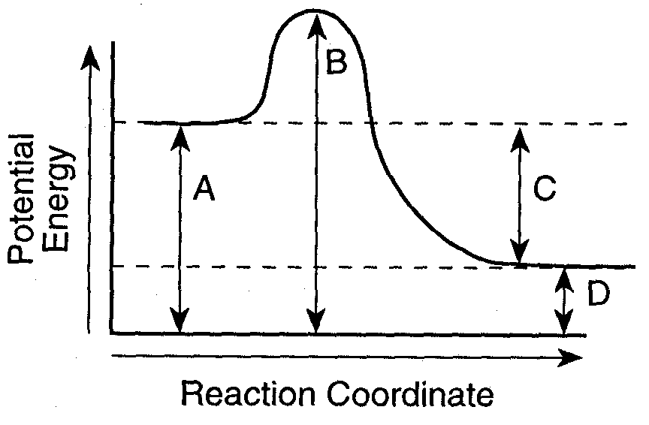

**F**

**E**

**A + B C + D + energy**



1. Is the above reaction ***endothermic*** or ***exothermic***? Exothermic

Explain why

**Energy (in the form of heat) is being released to its surroundings.**

1. What letter represents the **potential energy of the reactants**? A
2. What letter represents the **potential energy of the products**? D
3. What letter represents the **heat of reaction (ΔH)**? C
4. Draw an arrow to represent the **activation energy** of the forward reaction.

**Label the arrow E**

1. Draw an arrow to represent the **activation energy** of the reverse reaction.

**Label the arrow F**

1. What letter represents the **potential energy of the activated complex**? B
2. Is the reverse reaction **exothermic** or **endothermic**? Endothermic
3. The letters **A+E** and **C+D** represent what parts of a chemical reaction?

Potential Energy of the Activated Complex and Enthalpy of the products

**Page 638**

#55 the minimum energy that colliding particles must have in order to react.

**Answer questions #1-9 using the potential energy diagram below:**

**\*Assume energy is measured in kilojoules**

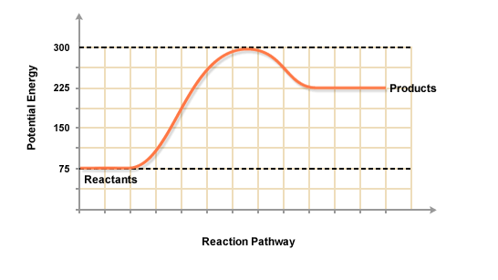

1. Is the above reaction ***endothermic*** or ***exothermic***? Endothermic

Explain why.

Energy in the form of heat is gained.

1. The reactants started with how much stored energy? 75 kJ
2. The products ended with how much stored energy? 225 kJ
3. Determine the value of **∆H** of the reaction. +150 kJ
4. How much energy in needed to activate the forward chemical reaction? 225 kJ
5. How much energy in needed to activate the reverse chemical reaction? 75 kJ
6. At the activated complex, the potential energy is equal to 300 kJ

**Page 639**

#85 20 kJ + 5 kJ = 25 kJ

#86 In the box below, sketch the potential energy diagram.

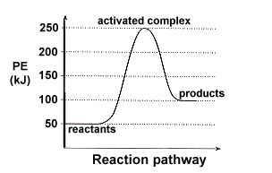

**Part V: Measuring Randomness- Entropy**

Using your glossary, define ***entropy.***

**A measure of disorder of a system; systems tend to go from a state of order (low entropy) to a state of maximum disorder (high entropy)**

**Pearsons SuccessNet On-line**

**Chapter 18 🡪 Concepts in Action: Entropy-Gone to the Dogs**

**Explore the model illustrating entropy and answer questions online.**

**Page 638-639**

#76 a. ice

b. sodium chloride cyrstals

#87 The change from a to b is spontaneous, favored by an increase in entropy. The change from b to c will not occur, because it would result in a decrease in entropy, causing the process to be nonspontaneous.

#88 a. yes

Explain why

A solid becomes a gas

b. yes

Explain why

A single solid becomes two products, one of them a gas.

c. no

Explain why

Two particles become one.

d. yes

Explain why

One particle becomes two.

**Part VI: Slowing Down or Speeding Up- Rates of Chemical Reactions**

All Group 2 metals react with dilute hydrochloric acid to give bubbles of hydrogen and a colorless solution of the metal chloride.

List 4 ways you would use to increase the rate of the following reaction.

**Mg(s) + HCl(aq) ----> H**2**(g) + MgCl**2**(s) + energy**

1. Increase the surface area of the magnesium metal.

2. Increase the concentration of the HCl(aq)

3. Increase the temperature

4. Add a catalyst to lower the activation energy

**Page 601**

#5 Chemical reactions involved in food spoilage occur faster at higher temperatures because more energy is available.

**Page 638**

# 56 c

**\*Refer to pages 600-601 in the textbook**

What does a catalyst do?

Lowers the activation energy (energy requirement for effective collisions)

**The graph below shows the reaction rate of the same reaction with and without a catalyst. Use it to help you answer the following questions.**

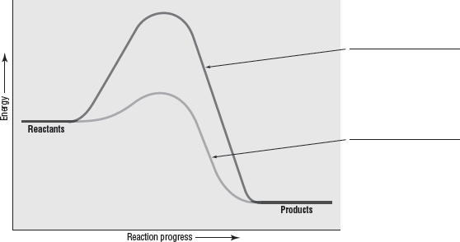

Without catalyst

With catalyst

a. Label each curve as ***with catalyst***or ***without catalyst***.

b. What does the graph show about the effect of a catalyst on the rate of a reaction?

Using a catalyst will make the reaction occur faster.

c**.** In a **chemical equation**, how do you show that catalysts are not consumed or chemically  
 altered during a reaction?

The catalyst is placed above the yield sign and do not become part of the

products.

d.A(n) inhibitor is a substance that interferes with the action of a catalyst.

**Page 640 - 641**

#102 a. **Fanning brings more oxygen into contact with the campfire.**

b. The ice cubes have a larger surface area than the block of ice, and

thus interact more with the warmer surroundings

c. MnO2 is a catalyst; the reaction occurs explosively

#107 Lowering the temperature of the jam slows down the rates of the reactions that cause the jam to spoil.

#110 decomposition reactions; Most decomposition reactions requires energy, in this case, in forms of heat and light.

**CHEMYSTERY-Explosive Sugar**

#112 The first explosion produced vibrations that shook surfaces in the warehouse. Sugar dust on these surfaces was thrown upward, resulting in a high concentration of sugar dust in the air. The high concentration of sugar dust increased the likelihood that particles of sugar would touch an overheated surface and ignite.

#113 To reduce the chance of an explosion, the concentration of sugar dust in the air must be kept low. Possible solution: the sugar refinery frequently clean the sugar dust from all surfaces.

**Part VII: Extension- Free Energy and Spontaneous Reactions**

1. Define Gibbs energy.

Represents the free energy available from the result of a chemical change to do work. This value is dependent on the heat of the reaction, entropy and temperature.

1. Using the equation in the article, solve the following problem:

Give that the changes in enthalpy and entropy are -139 kJ and

277 J/K respectively for the reaction given below, calculate the change in Gibbs energy. Then, state whether the reaction is spontaneous at 250C.

**C6H12O6(aq) ----> 2C2H5OH(aq) + 2CO2(g)**

This reaction represents the fermentation of glucose into ethanol (C2H5OH) and carbon dioxide, which occurs in the presence of enzymes provided by yeast cells. This reaction is used in baking.

|  |
| --- |
| **ΔG = ΔH -TΔS K = 250C + 273 = 298 K**  **ΔG = -139 kJ – 298K(.277 kJ/K)**  **ΔG = -139kJ – 82.55kJ**  **ΔG = -222kJ The reaction is spontaneous ☺** |

1. Relating Enthalpy & Entropy changes to Spontaneity (**ΔG = ΔH -TΔS)**

Complete the following table:

|  |  |  |  |
| --- | --- | --- | --- |
| **ΔH** | **ΔS** | **ΔG** | **Is the reaction spontaneous?** |
| **Negative** | **Positive** | **Negative** | Yes, all temperatures |
| **Negative** | **Negative** | **Either positive or negative** | Depends on temperature  Describe temperature conditions: T<**ΔH , ΔS** |
| **Positive** | **Positive** | **Either positive or negative** | Depends on temperature  Describe temperature conditions: T>**ΔH , ΔS** |
| **Positive** | **Negative** | **Positive** | Never |

**Page 634**

# 47 An increase in entropy favors a spontaneous reaction; a decrease favors a nonspontaneous reaction.

# 49 The reaction is spontaneous

#53 The reaction of nitroglycerine releases 1427 kJ of heat, and in the process converts 4 mol of a liquid into 29 mol of four different gases. Both enthalpy and entropy changes favor spontaneity.